**University of Macau**

**Faculty of Science and Technology**



**Fence Removal From Images**

***by***

**LAM PENG IAT No:** **DB625806**

Final Project Report submitted in partial fulfillment  
 of the requirements of the Degree of   
 Bachelor of Science in Computer Science

Project Supervisor

Prof. Chan Long

**DECLARATION**

I sincerely declare that:

1. I and my teammates are the sole authors of this report,
2. All the information contained in this report is certain and correct to the best of my knowledge,
3. I declare that the thesis here submitted is original except for the source materials explicitly acknowledged and that this thesis or parts of this thesis have not been previously submitted for the same degree or for a different degree, and
4. I also acknowledge that I am aware of the Rules on Handling Student Academic Dishonesty and the Regulations of the Student Discipline of the University of Macau.

Signature : _________________________

Name : LAM PENG IAT

Student No. : DB625806

Date 29 May 2020

**ACKNOWLEDGEMENTS**

I would like to thank my supervisor Prof. Chan Long for giving us a lot of help, and his suggestions help us to progress on the FYP. He explained the concept of the project, so that we can clearly know the problem, so that we can effectively improve the project.

**TABLE OF CONTENTS**

**CHAPTER 0. ABSTRACT 8**

**CHAPTER 1. INTRODUCTION 9**

1.1 Motivation 9

1.2 Research problem 9

1.3 Research purpose 9

1.4 Research contributions 10

**CHARTER 2. PREPARATION BEFOREHAND 11**

2.1 Image photography 11

2.2 Data 11

**CHARTER 3. FENCE PROCESSING 12**

3.1 Image acquisition 12

3.2 The process of identifying and analyzing image areas 13

3.3 Identification and extraction of fences 15

3.3.1 Fence extraction 15

3.3.2 Other extraction methods 16

3.4 Optimize the raised fence part 16

3.4.1 Expanded fence part 17

3.5 Remove the fence 17

3.5.1 Combine the mask image with the original image 17

**CHARTER 4. IMAGE RECOVERING 18**

4.1 Use pixel average to inpaint 18

4.1.1 The gradient is discretized vertically and horizontally 18

4.1.2 Gradient discretization 21

4.1.3 Using weights to repair the fence in a horizontal or vertical direction along the oblique direction 23

4.2 Impact of different repair methods on the output image 24

4.2.1 Harmonic Inpainting 24

4.2.2 Mumford-Shah Inpainting with Ambrosio-Tortorelli approximation 25

**CHAPTER 5. PROGRAM CODE 26**

5.1 Demo.m 26

**CHAPTER 6. EXPERIMENTS AND RESULTS 27**

6.1 Picture operation time 27

6.2 Simple results 27

6.3 Fail results 29

6.4 Result analysis 30

**CHAPTER 7. REKATED WORK 31**

**CHAPTER 8. CONCLUSION 32**

**CHAPTER 9.REFERENCES 33**

**LIST OF FIGURES**

Figure 2-1 Image folder 11

Figure 2-2 Object focusing images 11

Figure 2-3 Fence focusing images 11

Figure 3-1 Image acquisition 12

Figure 3-2 Object focusing image 12

Figure 3-3 Fence focusing image 12

Figure 3-4 Relation between the background, the fence, and the image plane. 13

Figure 3-5 Relation between the fence and the image plane when the fence are in focus 15

Figure 3-6 The fence part in the fence focusing image 16

Figure 3-7 Manually point the color pixel of the fence 16

Figure 3-8 Extraction fence 16

Figure 3-9 Expansion fence part 17

Figure 3-10 An image with fence mask 17

Figure 4-1 Restored image 24

Figure 4-2 Harmonic Inpainting 25

Figure 4-3 Mumford-Shah Inpainting with Ambrosio-Tortorelli approximation 25

**LIST OF TABLES**

Table 6-1 Calculation process time 27

Table 6-2 Sample results 27

Table 6-3 Fail results 29

**CHAPTER 0: ABSTRACT**

In daily life, take a photo is already an indispensable part of people's daily lives. As people have higher and higher requirements for photo quality, people often choose to use the method of retouching to remove or modify photos The part that is considered unnecessary, we often encounter obstacles when shooting, which affects the aesthetics of the photos we take.

For this, we need a processing tool that can provide us with the ability to repair pictures, So that we can use it to remove unnecessary fences and obstacles in the picture. Usually, this tool is divided into two parts, one part can detect the fence and obstacles in the picture, extract the fence part from the picture. The other part is the part that can repair the missing fence.

After our testing of various methods, we have selected a function that can automatically detect excess obstacles and fences for users, and at the same time, according to a large amount of information in the picture, the picture can be automatically repaired the blank part to satisfy the user Requirements for retouching. From the experimental results, his repair method has a repair effect on most photos with fences or obstacles.

**CHAPTER 1: INTRODUCTION**

**1.1 Motivation**

This project is based on the topics selected under the graduation requirements of the Cisc4000 Final Year Project. Since we are interested in remove the fence and the skills and knowledge required for the topics have been learned in the past four years, we think the skills and knowledge in past four years what we learn, it can help us complete this project, so we choose this project to be the topic of our project.  
  
**1.2 Research Problem**

It is an important issue to recover the occluded objects in the scene to obtain the restored original image. Because the research question is: how should we solve the extraction of the fence? How should we solve the image repair method? For this purpose, we propose two feasible methods, and then compare the two repair and extraction methods, so as to compare the final results, Seeking to get a more effective repair effect.

**1.3 Research purpose**

In this project, we use the Matlab to achieve remove the fence on the image, through with our understanding of the literature, and through the experimental results, we have achieved the following goals:

a. Remove fence

b. Extract fence

c. Advance of the fence

d. Remove the fence

e. Repair image

**1.4 Research contributions**

|  |  |  |
| --- | --- | --- |
|  | LAM KA CHON | LAM PENG IAT |
| Data collection | x | x |
| Image taken | x | x |
| Image filter | x |  |
| Programming | x | x |
| Image reprocessing |  | x |
| Image processing | x |  |
| Inpainting methods | x | x |
| Program test | x | x |
| Debug | x | x |
| Collection of papers | x | x |
| Report writing | x | x |
| Meeting note | x | x |
| Data testing | x |  |
| Result statistics | x |  |

**CHARTER 2. PREPARATION BEFOREHAND**

**2.1 Image photography**

Due to the large number of pictures required for testing, there are not enough resources on the Internet for us to test pictures of different fences. We chose to shoot ourselves. We chose to take a picture with a different focal length for each group of pictures, because the size of this will affect the repair effect. In order to obtain different data, some of our pictures are of different sizes.

**2.2 Data**

Our material photos are divided into two files: "fence" and "object", and are placed in their respective file folders, which allows us to make effective classification when processing images.

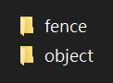

***Figure 2-1 Image folder***

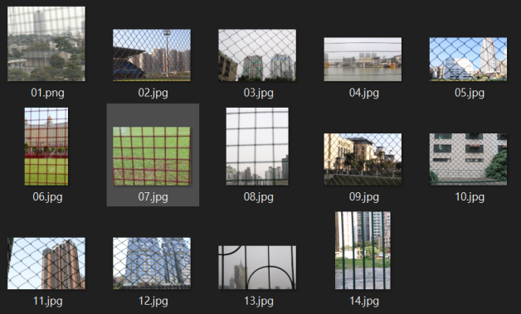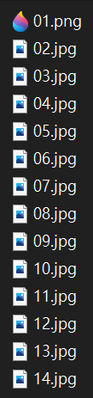

***Figure 2-2 Object focusing images***

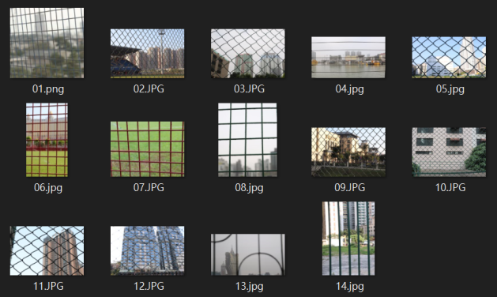

***Figure 2-3 Fence focusing images***

**CHAPTER 3: FENCE PROCESSING**

**3.1 Image acquisition**

Our proposed fence method uses two images, according to different focal lengths, to collect the background and the fence part (see Figure 3-1). One is the background part obtained from the out-of-focus foreground fence picture (see Figure 3-2). The other one is obtained from the defocused background image (see Figure 3-3).

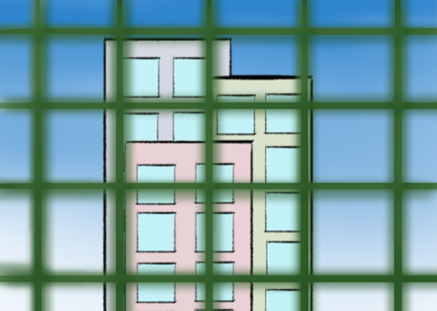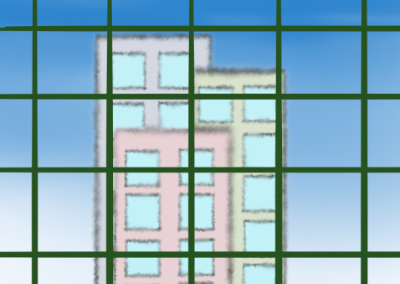

***(a)Object focusing image (b)Fence focusing image***

***Figure 3-1 Image acquisition***

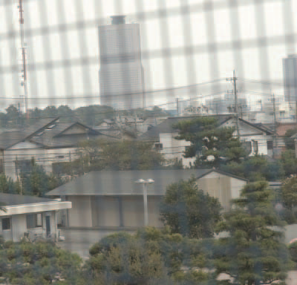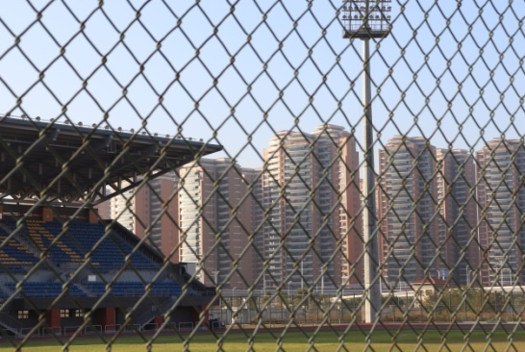

***Figure 3-2 Object focusing image***

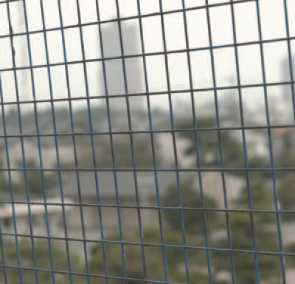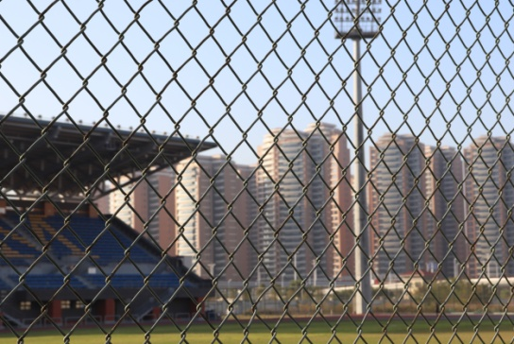

***Figure 3-3 Fence focusing image***

**3.2 The process of identifying and analyzing image areas**

We use a simple camera model consisting of a thin lens and an image plane [1] to explain the characteristics of the formula (1) [2].

If the distance from the object to the lens is a, the opposite is b, it means a and b can following this formula, f is the focal length of the lens in this formula.  


We can get the geometric relationship between the background, the fence and the image plane from *Figure 3-4*.

 is the distance from the background to the lens.

 is the distance from the lens to the plan.

 is the distance from the fence to the lens, and the distance of an must be less than .

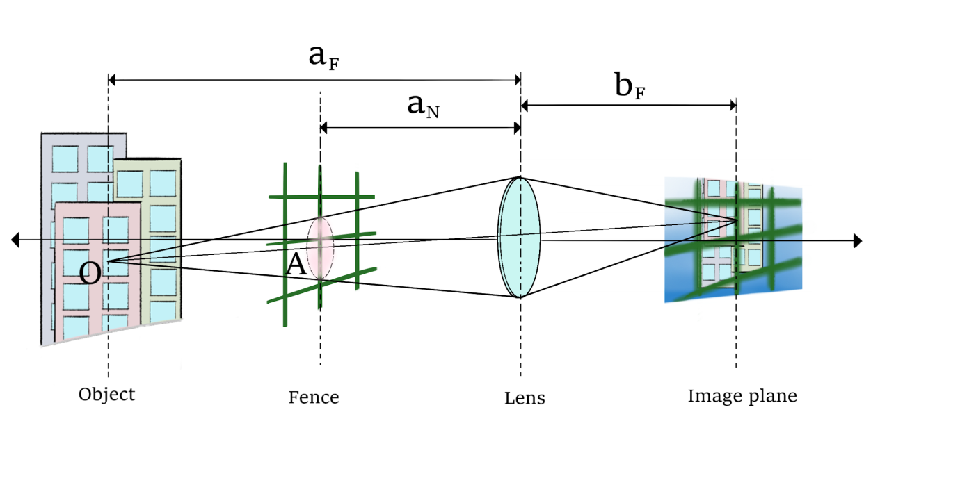

***Figure 3-4 Relation between the background, the fence, and the image plane.***

When the focus is on the background, this will produce blurred image points of the fence, which will produce blurred stripes of the image.

r is the blur radius

d is the lens frame



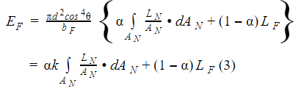

 is the distance between lens and the object.  
O is corresponds the point on the object.

The light reflected by O is focused at I on the image plane of the lens.



In equation (5),  is not affected by the value of ,

so equation (3) can become (5)

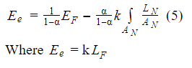  
  
Irradiance value  The required irradiance values are  and . In equation (5), we cannot directly obtain the value of (see Figure 3-5). So we need to establish the relationship equation between the irradiance values  En and 



According to the formula(6), AN corresponds to A’N with the following formula:



bN is the image distance, substitute  into formula(1),

 is the correction coefficient.

 is the average value of A’N illuminance value.



We can get  by substituting the equation.



If the blur radius r is known, then theαvalue of the fence area can be obtained by calculation, the  value of  and the background imaging map can be obtained by the average pixel value of the fence in this area, then the value of  can be obtained by the equation (9), and finally the shift is generated by the value of  Image of removing fence

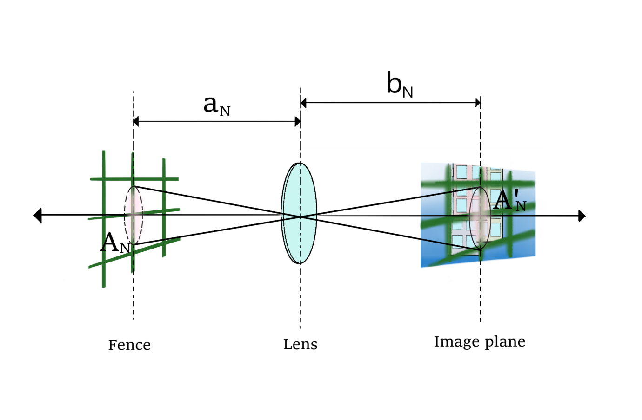

***Figure 3-5 Relation between the fence and the image plane when the fence are in focus***

**3.3 Identification and extraction of fences**

This part of the extraction fence, we carried out experiments based on this theory, the experimental results show that the fence of most pictures can be successfully separated.

**3.3.1 Fence extraction**

We grayscale the color image, then use the subtraction method, and then extract and then extract the fence, and correspond to the pixel position value of the picture fence of the clear background picture, so that the background pixel position in the image changes It is black and the rest are fences (see Figure 3-6).

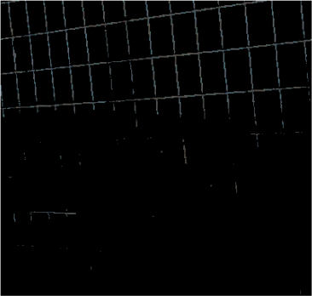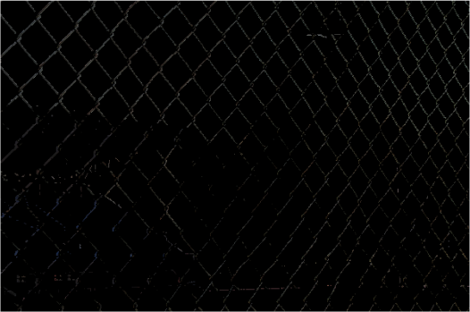

***Figure 3-6 The fence part in the fence focusing image***

**3.3.2 Other extraction methods**

The user can manually enter the position pixels of the fence (see Figure 3-7). The blue dots in the figure are the pixels of the points manually entered by the user. We can model the fence through the points entered by the user. By manually selecting the pixel position and automatically extracting the K pixels adjacent to the user input position, this advantage is to reduce the error during the automatic recognition of the fence When the user enters the wrong data, it will cause a deviation in extraction. The experimental results show that when the user inputs more than 200 location data, all the fences can be accurately extracted (see Figure 3-8).

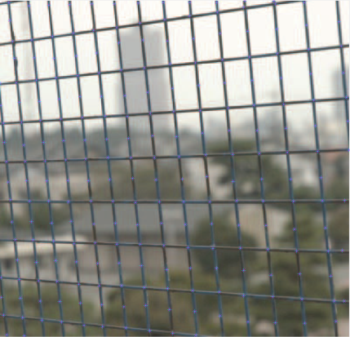

***Figure 3-7 Manually point the color pixel of the fence***

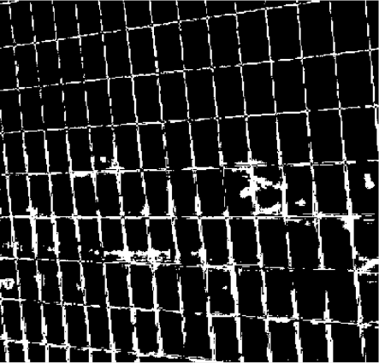

***Figure 3-8 Extraction fence***

**3.4 Optimize the raised fence part**

After extracting the fence, it is possible to extract the part that does not belong to the fence. In this case, the color of the fence is usually very close to the background image, so the mask image cannot completely cover the part of the fence, so Post-processing is required, such as increasing the selection range of each pixel of the fence pixels.

**3.4.1 Expanded fence part**

Due to the different focal lengths of the two photos, the scenes of the photographed image will have a slightly different size, which will cause the position of the fence of the two photos to deviate. Therefore, in the extraction part, we need to increase the selection range so that it can completely cover the fence part. (see Figure 3 -9)

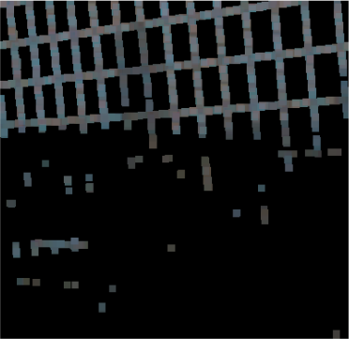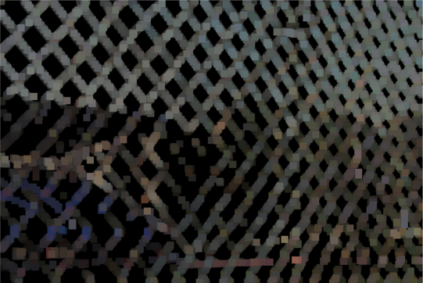

***Figure 3-9 Expansion fence part***

**3.5 Remove the fence**

This part is to merge the post-processed mask image and the background image to find out the position of the fence in the original image. Obtain the area of the fence area in formula (6) by calculation. The average value of all the pixel values in the fence area can finally obtain the value  of equation (6). Then, the value  is obtained based on the equation.

**3.5.1 Combine the mask image with the original image**

The post-processed mask image is overlaid on the original image. The pixels on the mask image correspond to the position of the original image, making the pixels in the fence part black (see Figure 3-10)

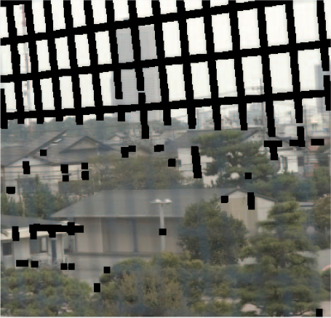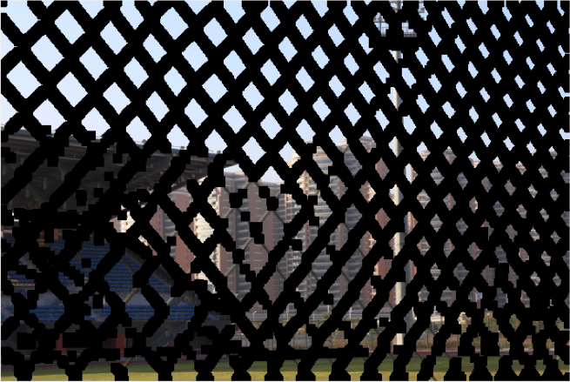

***Figure 3-10 An image with fence mask***

**CHAPTER 4: IMAGE RECOVERING**

**4.1 Use pixel average to inpaint**

The weighted average value of the gray values of adjacent pixels is used to calculate the gray value of unknown pixels. This method has a faster repair speed, but cannot maintain the scene structure in the picture. The result of the repair will be blurred.

In this method, the gradient discrete method of repairing the model in the horizontal and vertical directions is decomposed by using pixels within the range of nearby fence pixels (3 * 3).

We calculate the gradient components of adjacent pixels in the horizontal and vertical directions of the repaired pixel, and use the gradient components and the adjacent pixels to diffuse the information into the repaired area. This decomposition method can effectively repair the horizontal and vertical edge structures, but for the repair of inclined edge structures, it is easy to appear different structures that do not exist.

**4.1.1 The gradient is discretized vertically and horizontally**

Use the Total Variation repair model[3] to calculate the gradient component of the repair point along the vertical or horizontal repair fence, and transfer the gradient component and the information of the neighboring pixels to the repair point:



D is the repair area of the image, E is its neighborhood, u is the pixel, and the constraints of the formula (1) TV image repair model are:

  
The image restoration algorithm of the overall variational image restoration model minimizes equation (1) under the restriction of (2).

The gradient is decomposed in the horizontal and vertical directions, i, j are the horizontal and vertical coordinates of the pixel, I (i, j) is the repaired pixel, which is I (i, j-1), I (i, j + 1) , I (i_l, j), I (i + 1, j)



 are the represents of horizontal and vertical components in the repair area.

Because the distance between the upper and lower ends of the fence is relatively long, some fences have continuous pictures in the vertical and horizontal directions. Due to insufficient information available to each other, when repairing the vertical fence, the vertical information  is not considered, only the horizontal direction is considered. In contrast, the repair of the horizontal fence does not consider the vertical information , only the vertical square information.[4]

The divergence is approximately:



 respectively represent the two sides of the repair point, h is the step size, and w represents the direction of the repair area. In formula (4),  are calculated as follows::

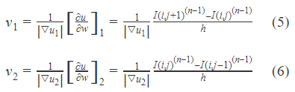

n is the number of current repairs, n-1 is the number of previous repairs, i and j in formulas (5) and (6) are the horizontal and vertical coordinates of the pixel,  Is the repaired pixel of the fence,  is a neighborhood pixel of the repaired pixel of the fence ,  is another neighborhood pixel of the repaired pixel  of the fence, and the variational solution gradient uses the repaired neighborhood (3 * 3) Eight pixels.

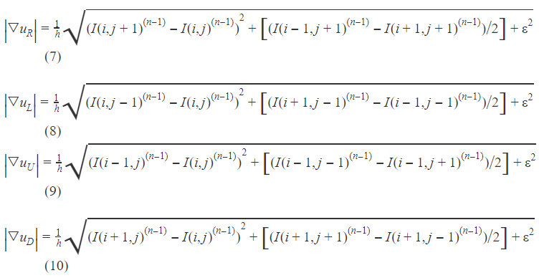

is the repaired pixel point of the horizontal / vertical fence the upper left corner pixel point;

is the repaired pixel point of the horizontal / vertical fence  neighboring pixels in the lower left corner;

is the repaired pixel point of the horizontal / vertical fence  the upper right corner pixel point;

is the repaired pixel point of the horizontal / vertical fence neighboring pixels in the lower right corner;

The transformation formula is as follows:

Equation (7) is used to achieve repair points along the horizontal direction to vertical scratches,  in Equation (15) is the pixel point after one iteration of repairing the vertical fence, i, j are vertical The horizontal and vertical coordinates of the repaired pixels of the fence.

Formula (8) is used to achieve the repair point of horizontal scratches along the vertical direction,  in formula (16) is the pixel point after horizontal scratches are repaired by one iteration, i and j are horizontal The horizontal and vertical coordinates of the repaired pixel of the scratch.

**4.1.2 Gradient discretization**

In the model of discretization of the gradient in the Total Variation format[5], the discretization of the gradient is in the direction of the diagonal of the square. The eight neighborhoods (3*3) of the repair points form a square. Four points are selected on the square, and four points are four points. It is a, b, c, d.

On the x’y’ coordinate axis, the distance between the half points is h, then the divergence of formula (2) is approximately:

Using the repair point eight neighborhood to calculate the four gradient components, the gradient components of a, b, c and d are:

Where n represents the number of current repairs, n-1 is the number of previous repairs of the current repair, and i and j in equations (18) to (21) are the horizontal and vertical coordinates of the pixel.

is the oblique direction repair pixel;

is the oblique direction repair pixelis the expected point of the upper neighborhood;

is the oblique direction repair pixelis the expected point of the lower neighborhood;

is the oblique direction repair pixel is the expected point of the left neighborhood;

 is the oblique direction repair pixel is the expected point of the right neighborhood;

is the oblique direction repair pixel is the expected point of the neighborhood in the lower left corner；

is the oblique direction repair pixel is the expected point of the neighborhood in the upper left corner；

is the oblique direction repair pixelis the expected point of the neighborhood in the lower right corner；

is the oblique direction repair pixelis the expected point of the neighborhood in the upper right corner；

The transformation formula is as follows:

Substituting equations (22) ~ (25) into equation (2):

Equation (26) is used to transfer information to fence repair points. The transmitted information includes gradient components and neighborhood pixel values, which are used to repair vertical and horizontal fences in the video sequence. in equation (26) is an oblique fence, after one iteration of repairing pixels, i and j are the horizontal and vertical coordinates of the repaired pixels of the fence.

**4.1.3 Using weights to repair the fence in a horizontal or vertical direction along the oblique direction**

Set a weight value of to the above, and combine the respective weight value with the formula to repair the fence in the image [6].

For the repair of vertical scratches,  is multiplied by equation (15) and is multiplied by equation (26):

Equations (27) and (28) are used to repair the vertical and horizontal fences in the image sequence, respectively, and can transmit both horizontal or vertical information and oblique information to the repair point. Among them, n represents the number of current repairs, and n-1 is the number of previous repairs of the current repair.

Repair the vertical or horizontal fences according to formula (27) or (28) respectively. If the set values of satisfy , the information in the horizontal or vertical direction and the information in the diagonal direction are mainly transmitted to the repair area Supplemented.

If , the information in the oblique direction is mainly transmitted to the repair area, and the information in the horizontal or vertical direction is supplemented. If , horizontal or vertical information and oblique direction information are transmitted to the repair point in equal proportion.[6]

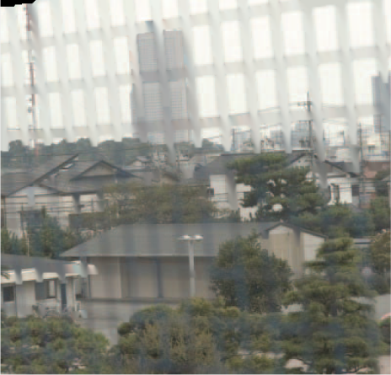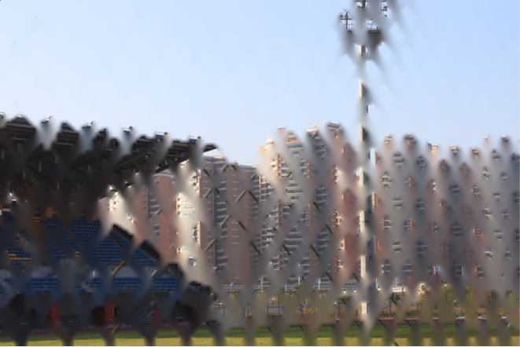

***Figure 4-1 Restored image***

**4.2 Impact of different repair methods on the output image**

We have used other repair methods, but they were not adopted by us. The repair effect is as follows

**4.2.1 Harmonic Inpainting**

Harmonic repair function [7]

This method finds the boundary data of the harmonic function to make the repair smoother. (See Figure 4-2)

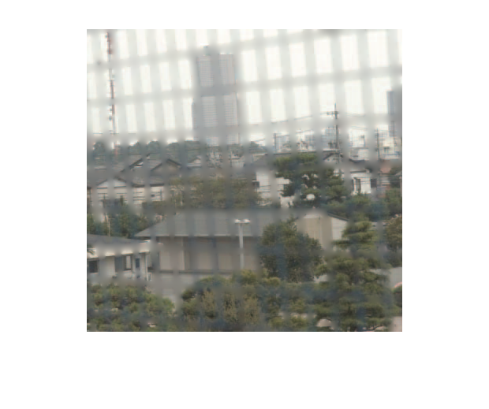

***Figure 4-2 Harmonic Inpainting***

#### 4.2.2 Mumford-Shah Inpainting with Ambrosio-Tortorelli approximation

The Mumford-Shah Inpainting with Ambrosio-Tortorelli approximation, this function by a piecewise smooth function[8]. (see Figure 4-3)

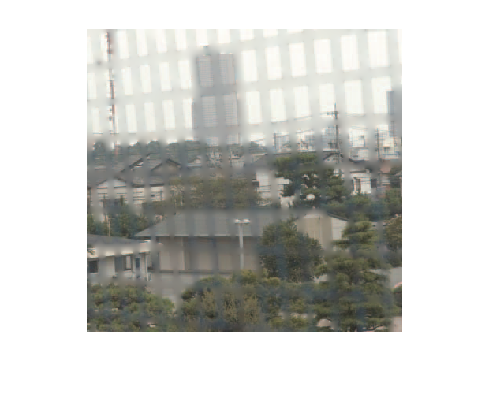

***Figure 4-3 Mumford-Shah Inpainting with Ambrosio-Tortorelli approximation***

**CHAPTER 5: PROGRAM CODE**

**5.1.1 Demo.m**

clear

close all

clc

%input the image focus background

I1=imread('01_1.png');

%convert color image to grayscale image

a=rgb2gray(I1);

%input the image focus fence

I2=imread('01_2.png');

%convert color image to grayscale image

b=rgb2gray(I2);

%the fence of image 2

aa=(b-(a-b));

%read length and width

[h,w]=size(aa);

%expand the fence

n=8;

%nn matrix

B=ones(n,n);

for i=1:h

for j=1:w

if aa(i,j)~=0

for l=1:3

I2(i,j,l)=0;

end

end

end

end

%expand fence of image2

mask=imdilate(I2,B);for i=1:h

for j=1:w

for l=1:3

if mask(i,j)>0

I1(i,j,l)=0; %make the fence color become black

end

end

end

end

figure(2)

% show the fence image

imshow(mask)

%inpaint the image

n_p=2;

%add n_p circle elements to periphery of the image

I1=padarray(I1, [n_p n_p]); for i=n_p:h+n_p

for j=n_p:w+n_p

for l=1:3

if I1(i,j,l)==0

frame=reshape(I1(i-n_p+1:i+n_p-1,j-n_p+1:j+n_p-1,l),1,(2n_p-1).^2); %compress the matrix into one dimension

num=(frame~=0);%the position of the 0 element in the fence

n_num=sum(num); %the number of 0 element in the fence

m=sum(frame)/n_num;%Average pixel value

I1(i,j,l)=round(m);%assign 0 pixels to the average pixel value

end

end

end

end

% show the inpaint image

I=I1(n_p+1:h+n_p,n_p+1:w+n_p,1:3);

figure(1)

imshow(I)

##### CHAPTER 6: EXPERIMENTS AND RESULTS

**6.1 Picture operation time**

In Table 5-1, we obtained the time required for the 8 experimental results according to the theory in Table 4-1. Table 5-1 describes the detailed information such as the size and name of the material photo, and calculates the required running time for each stage.

|  |  |  |  |  |  |  |
| --- | --- | --- | --- | --- | --- | --- |
| **Demo** | **Description** | **Image size** | **Time of extraction fence** | **Time of optimize fence** | **Time of inpainting** | **Total process time** |
| 1 | House | 384x400 | 0.04s | 1.40s | 0.49s | 1.93s |
| 2 | Playground | 6000x4000 | 1.40s | 1.03s | 2.94s | 5.37s |
| 3 | Building | 6000x4000 | 2.53s | 1.92s | 2.38s | 6.83s |
| 4 | Lakeside | 6000x3375 | 1.15s | 2.81s | 3.23s | 7.19s |
| 5 | Building | 6000x3375 | 1.25s | 2.17s | 5.49s | 8.91s |
| 6 | Casino | 2250x4000 | 0.62s | 1.01s | 1.08s | 2.71s |
| 7 | Grass | 4500x3375 | 0.96s | 0.73s | 1.57s | 3.26s |
| 8 | Building | 2697x3371 | 0.55s | 0.53s | 0.79s | 1.87s |

***Table 6-1: Calculation process time***

**6.2 Sample results**

We took 14 sets of pictures and experimented with Chapter 4's theory, and obtained 8 sets of successful results. We show the results in Table 5-2

|  |  |  |  |
| --- | --- | --- | --- |
| **Object focusing image** | **Fence focusing image** | **Mask image** | **Restored image** |
|  |  |  |  |
|  |  |  |  |
|  |  |  |  |
|  |  |  |  |
|  |  |  |  |
|  |  |  |  |
|  |  |  |  |
|  |  |  |  |
|  |  |  |  |

***Table 6-2: Sample result***

**6.3 Fail results**

|  |  |  |  |
| --- | --- | --- | --- |
| **Object focusing image** | **Fence focusing image** | **Mask image** | **Restored image** |
|  |  |  |  |
|  |  |  |  |
|  |  |  |  |
|  |  |  |  |
|  |  |  |  |

***Table 6-3: Fail results***

**6.4 Result analysis**

The above is the result of our experiment. Table 6-2 is a good repair image. Table 6-3 is the failed image. We use chapter 4's theory to quickly remove the fence and repair the image, but at the same time some pictures cannot be repaired very well, and a lot of picture information is lost. So we decided to use another set of methods to seek a better repair effect.

##### CHAPTER 7: RELATED WORK

In this project, we take material photos together, write reports, write meeting minutes, collect papers and test programs.

My main work is to implement the method of fence extraction and the early repair method, and the later repair method is led by my team members. The subtraction method is used to extract the part of the fence, and then the post-processing is used to optimize the extracted fence.

In the early extraction method, we used the surrounding pixels with the fence as the center, and then averaged all the pixels to obtain the repaired pixels. This method is very fast. For images close to black and white Good repair, but in terms of repair effect, there is still a lot of room for improvement. Finally, we decided to make a small improvement in the extraction fence method, and then use another repair method, that is, the later repair method to achieve better effect.

##### CHAPTER 8: CONCLUSION

In this project, we use the subtraction method to propose the fence, and then use the Gaussian blur method to post-process the extracted fence. At the same time, we have tried the extraction fence method that requires the user to manually select pixels Very good, but this method is too much work for the user, so it is not used.

We use pixel averaging near the fence and then repair the image, but the effect is not ideal. Later, we used another repair method, based on sample repair and pixel interpolation-based repair image. Coupled with the optimization of image upsampling and downsampling, although the repair speed is slower than the original method, the effect is better than the original.

##### CHAPTER 9: REFERENCE

**9.1 Camera model**

[1]Juyang Weng, Paul Cohen and Marc Herniou: “Camera Calibration with Distortion Models and Accuracy Evaluation,” IEEE Transactions on Pattern Analysis and Machine Intelligence, Vol.14, No.10, pp.965– 980, 1992.

**9.2Geometric optics formula**

[2]Reg G. Willson and Steven A. Shafer: “What is the Center of the Image?,” Journal of the Optical Society of America, Vol.11, No.11, pp.2946–2955, 1994.

**9.3Spline interpolation of images**

[3]Lee C.H.Restoring spline interp-olation of CT images[J] .IEEE Transactions on Medical Imaging, September 1983,2 (3): 142-149

**9.4Image restoration and segmentation**

[4]Li S.Z., Chan K.L., Wang H.Bayesian image restoration and segmentation by constrained optimization[C] .CVPR ' 96, Int.Conf.on Computer Vision and Pattern Recognition, Jun 1996, { 18}:1-6

**9.5Explore interpolation**

[5]Philippe Thevenaz, Thieny Blu, Michael Unser.Interpolation Revisited[J] .IEEE Trans on Medical Imaging, Jul.2000,19 (7): 739-758

**9.6Model imagce repair method**

[6]T. Bretschneider，0. Kao, P. J. Bonws. Removal of Verti-cal Scratchesin Digitised Historical Film Sequences Using Wavelet Decomposition[C]. NewZealand !Proceedings of the Image and Vision Computing，2000，：38_43

**9.7 Harmonic Inpainting**

[7]C. K. Chui, “An MRA approach to surface completion and image inpainting,” Applied and Computational Harmonic Analysis , 2009.

**9.8 Mumford-Shah Inpainting**

[8]Ambrosio, Luigi; Fusco, Nicola; Hutchinson, John E. (2003), "Higher integrability of the gradient and dimension of the singular set for minimisers of the Mumford-Shah functional",2003